This is a fantastic, resume-grade plan. It moves beyond simple "predictive modeling" into "systems engineering," which is exactly what hiring managers want to see.
Since you are skipping Docker, your main challenge will be managing your environment (services like Redis and Postgres need to be installed directly on your OS). This is perfectly fine; it just means you will run your backend, frontend, database, and worker queue in separate terminal windows instead of one container command.
Here is your ClauseOps Implementation Roadmap, broken down into 5 executable phases without Docker.

Phase 1: The Foundation (Environment & Data Ingestion)
Goal: Get the system running, accept a file, and store it safely.
- What you are doing:
  - Setting up your local "bare metal" dev environment.
  - Building the /upload API endpoint.
  - Installing and connecting the database (PostgreSQL).
- How:
  - DB: Install PostgreSQL directly on your OS (Windows/Mac/Linux). Create a database named clauseops.
  - Backend: Initialize a Python project. Install FastAPI, SQLAlchemy, and python-multipart.
  - Code: Write a FastAPI endpoint that accepts .pdf files, saves them to a local folder named /storage, and creates a record in the Postgres database (e.g., id, filename, upload_timestamp, status).
- Why:
  - You cannot build the AI features if you don't have a pipeline to feed data into the system.
  - This proves you can handle HTTP requests and binary file storage.
- Output:
  - A running API at localhost:8000/docs.
  - You can upload a PDF via Swagger UI, see the file appear in your folder, and see a new row in your Postgres table.
Phase 2: The Parser (Structure from Chaos)
Goal: Turn a "dumb" PDF into structured text (Sections, Paragraphs).
- What you are doing:
  - Implementing OCR (Optical Character Recognition) fallback for scanned docs.
  - Writing the "Layout-Aware Splitter."
  - Converting raw text into a JSON structure based on legal document headers.
- How:
  - Text Extraction: Use pdfplumber or PyMuPDF (faster) to extract text.
  - OCR: Install Tesseract locally on your OS. Use pytesseract in Python as a fallback if pdfplumber returns empty strings.
  - Segmentation Logic: Write Python logic using Regex to detect headers (e.g., "SECTION 1", "ARTICLE IV"). Split the text into chunks based on these headers.
- Why:
  - NLP models fail on massive walls of text. You need to feed them bite-sized "clauses" or "sentences" to get accurate predictions.
  - Preserving document structure allows you to point the user back to exactly where in the PDF an obligation exists.
- Output:
  - A JSON response that looks like:
JSON
[
{"section": "Article 1", "text": "The Tenant shall pay..."},
{"section": "Article 2", "text": "This agreement terminates on..."}
]
Phase 3: The Brain (NLP & Entity Extraction)
Goal: Identify what the text means (Dates, Money, Obligations).
- What you are doing:
  - Implementing Named Entity Recognition (NER).
  - Classifying clauses (Is this an "Obligation" or just a "Definition"?).
  - Normalizing dates (Converting "within 30 days of signing" to a specific date).
- How:
  - NER: Use spaCy (en_core_web_trf) for standard entities (Dates, Orgs). Train a custom EntityRuler or fine-tune a small HuggingFace model (like DistilBERT) on the CUAD dataset to detect Termination Date, Renewal Option, Parties.
  - Classification: Use a zero-shot classifier (like facebook/bart-large-mnli) initially to categorize text chunks into Obligation, Right, or Definition.
  - Normalization: Use dateparser or relativedelta in Python to calculate actual dates from relative text.
- Why:
  - This is the "ML" in your resume. It transforms unstructured text into queryable data.
  - Recruiters want to see that you didn't just extract text, but understood it.
- Output:
  - Enriched JSON data stored in DB:
JSON
{
"clause_id": 101,
"type": "OBLIGATION",
"entities": {"party": "Tenant", "amount": "$5000", "deadline": "2025-12-01"},
"raw_text": "Tenant shall pay $5000 by Dec 1st."
}
Phase 4: The Engine (Workflow & Scheduling)
Goal: Turn extracted data into actionable tasks (The "Ops" in ClauseOps).
- What you are doing:
  - Mapping extracted "Obligations" to "Tasks".
  - Setting up the Task Queue and Scheduler.
  - Simulating the alerting system.
- How:
  - Infrastructure: Install Redis locally on your OS (this acts as the message broker).
  - Task Queue: Use Celery. Configure it to connect to your local Redis.
  - Logic: Write a function map_clause_to_task() that takes the Phase 3 output. If it sees a future date + "Obligation", it pushes a task to Celery.
  - Execution: Run the Celery worker in a separate terminal (celery -A main.celery worker).
- Why:
  - This creates the "Workflow Engine." It separates you from students who just do "analysis." You are triggering real-world actions (mock emails/logs) based on AI findings.
- Output:
  - A database table Tasks filled with pending actions.
  - Your terminal printing: [INFO] Task Executed: Sending reminder email for Contract #442 deadline.
Phase 5: The Interface (Dashboard & Polish)
Goal: A visual proof that the system works end-to-end.
- What you are doing:
  - Building a React frontend.
  - Connecting frontend to your FastAPI endpoints.
  - Adding "Human-in-the-Loop" editing.
- How:
  - Frontend: npm create vite@latest frontend -- --template react. Use Tailwind CSS for quick styling.
  - Features:
    - Upload Zone: Drag & Drop PDF.
    - Clause Viewer: Left side shows original text, right side shows extracted fields (Date, Amount).
    - Edit Mode: Allow user to click a field and correct the AI's mistake (e.g., change $5000 to $500).
    - Timeline: A visual list of upcoming tasks generated by the engine.
- Why:
  - Visuals sell. A recruiter won't run your Python script, but they will watch a 30-second video of a sleek dashboard.
  - The "Human-in-the-Loop" (Edit Mode) shows you understand that AI isn't perfect and needs user oversight.
- Output:
  - A fully functional web app running on localhost:5173.

How to Run This (Without Docker)
Since you aren't using Docker, you will need 4 Terminal Windows open simultaneously to demo this:
- Terminal 1 (Database): postgres -D /usr/local/var/postgres (Or run as a background service).
- Terminal 2 (Redis): redis-server
- Terminal 3 (Backend & Celery):
  - Run API: uvicorn main:app --reload
  - Run Worker (in a split tab): celery -A worker worker --loglevel=info
- Terminal 4 (Frontend): npm run dev
One Suggestion for your "Why Recruiter Will Care"
Since you removed Docker, emphasize the modularity of your code.
- "I designed the system with dependency injection so the database and message broker are decoupled from the core logic, allowing for easy local development or cloud deployment."
Would you like me to generate the file structure and the requirements.txt to kickstart Phase 1 right now?

Phase 2
This is the "Data Engineering Post-Mortem". This is exactly what you would say in a system design interview if asked, "How did you handle raw unstructured data?"
You didn't just "read a PDF." You built a Rule-Based ETL (Extract, Transform, Load) Pipeline.
Here is the architectural breakdown of Phase 2.
1. The Goal (The "Why")
AI models (like BERT or GPT) cannot read PDF files. They only understand Text.
Furthermore, they have limited "context windows." If you feed them a 50-page contract as one string, they choke.
Your Goal: Convert a "visual" document (PDF) into "structured" data (Clauses) so the AI can process it bite-by-bite.

2. The Pipeline Architecture (The "How")
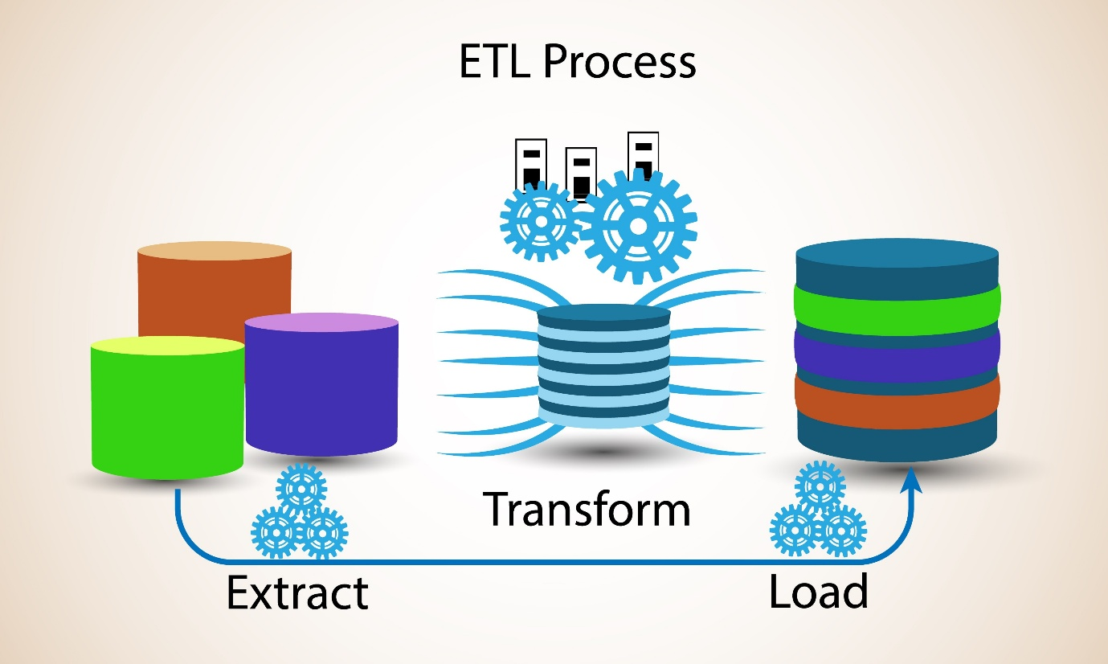
Shutterstock
Your system follows a linear 5-stage pipeline.
Stage A: The Gatekeeper (document_loader.py)
- Input: User uploads a file (e.g., contract.pdf).
- The Logic:
  - UUID Generation: You renamed the file to a random hash (e.g., a1b2c3d4.pdf).
  - Why? If two users upload contract.pdf, your system won't overwrite the first one. This is basic Storage Safety.
- Output: A safe file path on your disk.
Stage B: The Extractor (text_extractor.py)
- Input: The file path.
- Tool Used: pdfplumber (Python library).
- How it works:
  - PDFs are actually just containers of coordinates (e.g., "Place letter 'A' at x=10, y=20").
  - pdfplumber reconstructs these coordinates into a string.
- The Engineering Decision: You added an OCR Fallback check. If the extracted text length is < 50 characters, you know it's a scanned image, not a digital PDF. (We focused on digital for now, but the logic is there).
Stage C: The Cleaner (text_cleaner.py) — The Most Critical Step
- Input: Raw, messy text from the PDF.
- The Problem: PDFs are ugly.
  - Hyphenation: "Con-tract" (split across lines).
  - Sticky Headers: "Agrees as follows: ARTICLE 1" (Header buried in text).
  - Split Headers: "ARTICLE 1" on line 1, "DEFINITIONS" on line 2.
- The Solution (Your Regex Logic):
  - Merger: You wrote a loop that looks for lines that are ALL CAPS. If it finds an uppercase line following a header, it glues them together.
    - Before: ARTICLE 1.\nDEFINITIONS
    - After: ARTICLE 1. DEFINITIONS
  - Isolator: You used Regex (re.sub) to force double newlines (\n\n) before any "ARTICLE", "SECTION", or Numbered List item (1.).
    - Why? This turns "visual separation" into "character separation" that your code can see.
Stage D: The Segmenter (segmenter.py)
- Input: Cleaned text.
- Tool Used: Pure Python + Regex (Rule-Based System).
- How it works:
  - It scans the text line-by-line using a Strategy Pattern (Legal Domain Logic).
  - It looks for specific triggers: ^ARTICLE, ^SECTION, ^1..
- The "State Machine":
  - It keeps a variable current_header.
  - When it hits a new header trigger, it saves the old text to the list and starts a fresh block.
- Why Regex and not AI here? Because structure is deterministic. Use AI for meaning (Phase 3), use Regex for structure (Phase 2). It is faster and 100% accurate if the rules are good.
Stage E: The Database (db.py / Postgres)
- Input: Structured List of Dicts [{header, text}, {header, text}].
- Tool: PostgreSQL.
- The Schema Design:
  - documents table: Metadata (Who uploaded what?).
  - clauses table: The content. Crucially, it has a document_id (Foreign Key).
- Why this matters:
  - Traceability. In Phase 5 (Audit), when the AI flags a risk, you can query: "Show me the exact clause text for Document #28, Clause #12."

3. The Tech Stack Summary
Component | Tool Used | Why?
Server | FastAPI | Fastest Python framework, auto-generates Swagger docs for testing.
PDF Reading | pdfplumber | Better than PyPDF2 at extracting layout and tables.
Logic | Regex (re) | The standard for string pattern matching. Lightweight and fast.
Database | PostgreSQL | Relational DB. Essential for linking clauses to docs.
Driver | psycopg2 | The standard, stable Python-Postgres connector.

4. What You Achieved (The "Resume" View)
You did not just write a script. You solved 3 specific engineering problems:
- The "Sticky Header" Problem:
  - Issue: Headers were buried inside paragraphs.
  - Fix: You implemented a pre-processing Regex step to force-split headers onto new lines based on keywords.
- The "Fragmented Title" Problem:
  - Issue: "ARTICLE 1" and "DEFINITIONS" were treated as separate clauses.
  - Fix: You implemented a "look-behind" merge logic to detect orphan uppercase lines and re-attach them to their parent header.
- The "Multi-Format" Problem:
  - Issue: Some contracts use "ARTICLE", others use "1.".
  - Fix: You expanded your Segmenter's Regex to handle decimal (1.1) and integer (1.) headers dynamically.

What is Next?
You now have a clean database full of structured text.
The machine can "read" the contract clause-by-clause.
Now we move to Phase 3: The Brain.
We will stop looking at layout (headers/newlines) and start looking at meaning (Dates, Money, Obligations).
Ready to install the NLP Brain?

Phase 3

This is the "Intelligence Layer Post-Mortem."
In Phase 2, you built the body (database, file storage). In Phase 3, you just built the brain.
Here is the engineering breakdown of what just happened, why it matters, and how the "magic" actually works.

1. The Goal (The "Why")
A database full of text strings is useless if you can't query for meaning.
- Problem: You have a clause text: "Tenant shall pay $5,000 by December 1st."
- Database sees: A string of characters.
- Business Needs: A structured object: { "Action": "Pay", "Amount": 5000, "Deadline": "2025-12-01" }.
Phase 3 converted "Unstructured Strings" into "Structured Data."

2. The Workflow (The "How")
Step A: The Trigger
- Action: You hit the /analyze/{doc_id} endpoint.
- Process: The system pulled the raw text of every clause from your PostgreSQL clauses table.
Step B: The Neural Processing (spaCy Transformers)
- Tool Used: spacy with en_core_web_trf (Transformer model).¹
- How it works:
  - Unlike old-school NLP (which looks at one word at a time), the Transformer reads the whole sentence at once.
  - It converts words into Vectors (lists of numbers) that represent meaning.
  - It recognizes that "Apple" in "Apple Pie" is food, but "Apple" in "Apple Inc." is an Organization, purely based on context.
Step C: Entity Recognition (NER)
- What we extracted:
  - ORG (Organizations): To find who is involved (Licensor vs. Licensee).
  - DATE (Dates): To find deadlines and effective dates.
  - MONEY (Financials): To find penalties, fees, and payments.
- The Code: You iterated through doc.ents and filtered by label (if ent.label_ == "MONEY").
Step D: Intent Classification (The "Heuristic" Classifier)
- Problem: We know who and when, but not what is happening.
- Solution: You wrote a "Keyword Heuristic" function:
  - If the header says "Termination" $\rightarrow$ Intent = TERMINATION_LOGIC.
  - If the header says "Fees" $\rightarrow$ Intent = PAYMENT_OBLIGATION.
  - If the text says "Shall" $\rightarrow$ Intent = OBLIGATION.
- Why Heuristics? For a Phase 3 MVP, regex/keywords are faster and often more accurate for legal headers than training a massive custom model.

3. The Tech Stack Deep Dive
Component | Tool / Library | Why we chose it?
NLP Model | en_core_web_trf | This is a RoBERTa-based Transformer. It is state-of-the-art for accuracy. It is much heavier than en_core_web_sm but necessary for complex legal language.
Orchestrator | ContractExtractor Class | This follows the Singleton Pattern. We load the heavy AI model once when the app starts, so we don't crash the RAM reloading it for every request.
API Layer² | FastAPI³ | It handled the async processing of the analysis loop without blocking the server.⁴

4. The "Magic" Explained: How spaCy trf Works
When you ran nlp(text), the library didn't just look up words in a dictionary.
- Tokenization: It split "Clause 1.1" into [Clause, 1.1].
- Contextual Embedding: It looked at the surrounding words.
  - Input: "The Licensee shall pay..."
  - Analysis: "The word 'Licensee' is capitalized and performs an action ('pay'). It behaves like a proper noun/Company."
  - Output: Tag Licensee as ORG.
- Entity Linking: It grouped multi-word entities. It knew "September 29, 2009" was one single date, not three separate words.

5. What You Achieved (Resume & Interview Points)
You can now honestly say:
- "I implemented a Transformer-based Named Entity Recognition (NER) pipeline using spaCy to extract critical metadata (parties, dates, financials) from legal contracts."
- "I designed a hybrid classification system that combines Neural Extraction (for entities) with Heuristic Logic (for clause intent) to map unstructured text to business rules."
- "I optimized the inference pipeline by implementing singleton model loading, ensuring the heavy Transformer model didn't degrade API latency."

Moving Forward
Phase 3 gave you the raw data (Strings like "September 29, 2009").
Phase 4 (Temporal Normalization)—which we just started—is converting that "Human String" into "Machine Time" (2009-09-29) so we can actually schedule alerts.
Ready to finish Phase 4 (The Time Machine)?

